

FLAVOURZILLA

**Submitted By:**

|  |  |
| --- | --- |
| **Ashita Vijay Seth** | **Jalanki Nayak** |
| 181500145  (Front-end and Back-end Developer) | 181500291  (Front-end and Back-end Developer) |

**Project Information:**

|  |  |
| --- | --- |
| Title of Project | Flavourzilla |
| Technical Details | Hardware Requirements:  PC of minimum 2 GB RAM and 500GB Hard disk  Software Requirements:  Text Editor (VS Code, Sublime) (For Developing)  Google Chrome (For Hosting) |
| Project Implementation Details | Fully Implemented |
| Project Working Period | Start Date: 13 August 2021  End Date: 22 August 2021 |

**Summary of the Project Work:**

|  |
| --- |
| This document lays out a project plan for "Flavourzilla" a cooking website for online recipes. This website provides food recipes according to their need whether it is according to their mealtime, cuisine, or what type of ingredients they want to use. All the recipes are categorized into several sections to make the website more user-friendly so the user finds its right choice in a negligible amount of time. The user also has the advantage of saving, downloading, and uploading their favorite recipes to share with the world. |

**ABSTRACT**

The project ‘**Flavourzilla**’ is a web-based application. This is a project developed to provide details and ways of cooking various recipes. This project enables users to learn and cook various types of recipes according to their needs. This application provides the newest and most popular recipe details. A user can also construct its various recipes and can share them with the whole world through this. Different types of communities, recipe articles, and links are provided in this application. Users can also download the recipe details.

**CONTENTS**

|  |  |
| --- | --- |
| Synopsis | ii |
| Abstract | iii |

1. **Introduction ...…………………………………………….……………………...…….3-8**
   1. Motivation …….……………...………………………………….…………………..3-4
   2. Objective………….…………...……………………………………………………......4
   3. Technologies and Tools Used ...……………………………………………………..4-8
      1. HTML ………………………………….……….................................. 4-5
      2. CSS …………………………………….…………………………………5
      3. JavaScript ……..………………….…………………......………………..6
      4. Php ………………………………..…………………….…………….. 6-7
      5. SQL……………………………………………………………………….7
      6. Text Editor ……………………………………………………………….8
      7. phpMyAdmin …………………………………………………………… 8
2. **Software Requirement analysis ...…………………………………………………...9-12**
   1. Problem Statement…………………………….……………….…...………………….9
   2. Define Module and Functionalities…………….………………...………………..10-12
      1. Application description………….………………………………........9-10
      2. Functional Requirement……………………………………………...….11
      3. Non-Functional Requirement….………………………………………...12
3. **Software Design ...…………………………………………………...…………...….13-18**
   1. Data Flow Diagram………………………….…………………………...………….13
   2. UML Diagram…..……………………………….……………………...…………14-15
      1. Sequence Diagram.………………...…………………...…………….….14
      2. Use Case Diagram………….….……………………....……………...…15
   3. Database Design …...………………………………………...……...…………….16-18
      1. ER Diagram ……………………………….…...………………………..16
      2. Table Description…..………………………….…………………….17-18
4. **Implementation and User Interface………………………...………………….......19-23**
5. **Conclusion and Future Work ………………………………………………………….24**
6. **Bibliography …………………………………………….……………………….…...25**
7. **Appendices ……………………………………………………………………….... 26-28**

**INTRODUCTION**

"FOOD MAY BE ESSENTIAL AS FUEL FOR THE BODY, BUT GOOD FOOD IS FUEL FOR THE SOUL". A Healthy and tasty food is what we all need but unfortunately, everyone does not have the art of making healthy and most important, tasty food. To help them, this project i.e. ***FLAVOURZILLA*** will help them by providing a wide range of food recipes of different categories along with videos and required ingredients which will help the user in making delicious and healthy food. The whole Website will revolve around the user and their comfort. The user module will help the user to find out their desired recipes. Recipes will be divided into three categories - Meal Timings, Ingredients, and Cuisine. In each category, the user can find the relevant recipes which will contain an ingredient list, a set of instructions to prepare the food, and a video tutorial that makes understanding easier. User can view a limited number of recipes as a visitor and after that, he/she will have to register themselves to view more recipes. After registering themselves, user can manage their profile, rate a recipe, Upload their recipe in the desired category and share their opinion about a recipe which will help in further improvement in recipes.

* 1. **MOTIVATION**

Motivation is something that initiates, guides, and encourages persons or groups to give their best performance and help in reaching the desired goal. The main motivation behind this project is to provide an all-in-one place for food lovers which will help those people who have little or no knowledge about cooking and also don't have enough time to explore different platforms for the recipe. No person needs to learn cooking as long as he/she is at their home but when they have to leave their home to study or for a job, then sometimes a situation comes when they have to cook their food. Nowadays many people leave their homes for studies or jobs. Some of them live as paying guests where they get their food from outside but some live in rented houses where they have to make their meals. Due to their studies or jobs, people don't have enough time to explore a healthy dish by surfing on the internet. To help them, we are trying to make this project where users can find a wide range of recipes that will help them in making new and healthy dishes. All the recipes will be divided into different categories and subcategories which will save the time of the user and will help them in reaching their desired recipe easily

* 1. **OBJECTIVE**

The project objective is to deliver the cooking recipes through an online platform. This project is an attempt to provide the advantages of online watching and searching for customers. It helps to provide recipes from everywhere to anywhere through the internet using this website. There are numerous cooking websites across the internet which have a wide range of dishes of many categories but there is a limitation of these websites that customers have to search a lot to find a particular dish of their choice, and may not get proper guidance and ingredients to make a perfect dish. This project focuses on reducing the human effort to find the right dish by making the system more user-friendly by categorizing the whole into many different sections and searching can be done through various factors like ingredients required or by meal timing.

* 1. **TECHNOLOGIES AND TOOLS USED**
     1. **TECHNOLOGIES**

**HTML**

Stands for "Hypertext Markup Language". HTML is the language used to create web pages. "Hypertext" refers to the hyperlinks that an HTML page may contain. "Markup language" refers to the way tags are used to define the page layout and elements within the page. HTML is a text-based approach to describing how content contained within an HTML file is structured.

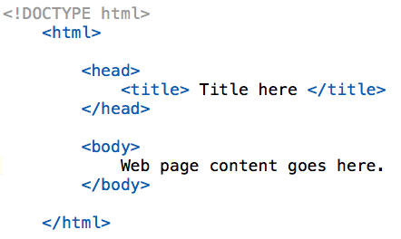

**CSS**

CSS stands for Cascading Style Sheets. CSS describes how HTML elements are to be displayed on the screen, on paper, or in other media. CSS saves a lot of work. It can control the layout of multiple web pages all at once. External stylesheets are stored in CSS files. CSS helps Web developers create a uniform look across several pages of a Web site. While CSS is great for creating text styles, it is helpful for formatting other aspects of Web page layout as well.

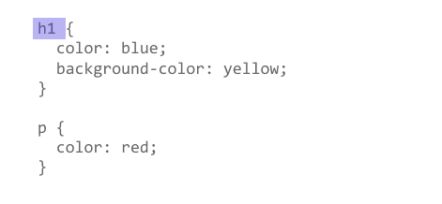

**JavaScript**

JavaScript is a programming language commonly used in web development. It was originally developed by Netscape as a means to add dynamic and interactive elements to websites. JavaScript is a client-side scripting language, which means the source code is processed by the client's web browser rather than on the webserver. This means JavaScript functions can run after a web page has loaded without communicating with the server.

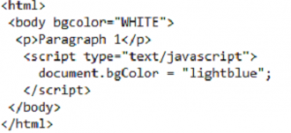

**Bootstrap**

Bootstrap is a free and open-source front-end development framework for the creation of websites and web apps. The Bootstrap framework is built on HTML, CSS, and JavaScript (JS) to facilitate the development of responsive, mobile-first sites, and apps. Responsive design makes it possible for a web page or app to detect the visitor’s screen size and orientation and automatically adapt the display accordingly. Created by a designer and a developer at Twitter, Bootstrap has become one of the most popular front-end frameworks and open source projects in the world.

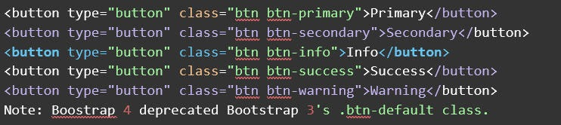

**PHP**

PHP stands for "Hypertext Preprocessor". PHP is an HTML-embedded Web scripting language. This means PHP code can be inserted into the HTML of a Web page. The output from the PHP functions on the page is typically returned as HTML code, which can be read by the browser. Because the PHP code is transformed into HTML before the page is loaded, users cannot view the PHP code on a page. This makes PHP pages secure enough to access databases and other secure information.

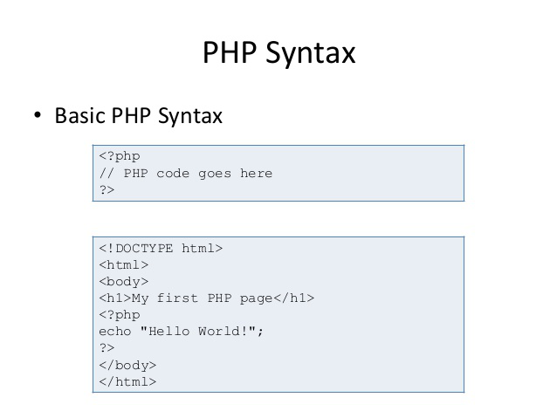

**SQL**

Structured Query Language (SQL) is a programming language that is typically used in relational databases or data stream management systems. It was developed by IBM in the early 1970s and is now an official standard recognized by the American National Standards Institute (ANSI) and the International Organization for Standardization (ISO). SQL is a language to operate databases; it includes database creation, deletion, fetching rows, modifying rows, etc. All the Relational Database Management Systems (RDMS) like MySQL, MS Access, Oracle, Sybase, Informix, Postgres, and SQL Server use SQL as their standard database language.

* + 1. **TOOLS**

**Text Editor**

For many developers, a trusty text editor is all you need for even the most complex Web Applications. Different types of text editors are used for coding in different programming and scripting languages. Some of them are Sublime Text 3, VS Code, Notepad++, etc.

**phpMyAdmin**

 phpMyAdmin is a free software tool written in PHP, intended to handle the administration of MySQL over the Web. phpMyAdmin supports a wide range of operations on MySQL and MariaDB. Frequently used operations (managing databases, tables, columns, relations, indexes, users, permissions, etc) can be performed via the user interface, while you still can directly execute any SQL statement.

**SOFTWARE REQUIREMENT ANALYSIS**

**2.1 PROBLEM STATEMENT**

Over the years Globalization, advances in technology, changing gender roles, and climate change have had a huge impact on how we live our lives. Along with this, time has also changed our eating habits. Previously, people used to eat a limited variety of food repeatedly. Innovations in foods were not so common and trying new recipes was not so interesting for the people. But as time has passed, we can see a drastic change in an individual's eating habits and taste. Now, people always like to try new dishes of different cuisines, explore different tastes, and try to do innovations and experiments with raw ingredients. Everyone wants to have good food in different flavors and tastes but don't know how to prepare it. Usually, when people try to make a new dish, the very first thing they do is search for it on Google. Their primary concerns are always about finding the required raw ingredients, their relative quantity, set of instructions to prepare the food, and most importantly, a related video from where they can see the preparation procedure which will help them in hands-on preparation of the food. But unfortunately, they don't find all these things (Ingredients, Steps of preparation, and video tutorial) in a single place and to do so, they have to visit numerous platforms like websites or applications or YouTube which is quite time-consuming and hectic. Many times, people give up their plan of cooking the dish and order it from restaurants because they don't find enough resources which could help them in preparing food. To resolve all these issues, a platform should be there which have all the features i.e. different categories of food (based on Meal timings, Required Ingredients, Cuisine) along with their ingredient requirement, preparation steps and video tutorial which will help the people in making new dishes and exploring the new flavors.

**2.2 DEFINE MODULES AND THEIR FUNCTIONALITIES**

**2.2.1 Introduction**

The Software Requirement Specification is designed to document and describe the agreement between the customer and developer regarding the software product. This document lays out a project plan for "Flavourzilla" a cooking website for online recipes. This website provides recipes of foods according to their need whether it is according to their mealtime or what type of ingredients they want to use. All the recipes are categorized into several sections to make the website more user-friendly so the user finds its right choice in a negligible amount of time.

**2.2.2 Purpose**

Defining and describing the functions and specifications of the ***Flavourzilla*** website is the primary goal of this Software Requirement Specification (SRS). Describing all the modules, their functionalities, the functional and non-functional requirement of our website is the main purpose of this SRS.

**2.2.3 Scope**

The scope of this project named ***Flavourzilla*** is to provide a user-friendly and easy-to-use cooking website which can be used for preparing a meal in less time or just to A Relational Database Management System (RDBMS) is used to store all the details related to users, products, and owner.

**2.3.4 Overall Description**

***Flavourzilla*** is an online cooking website for food recipes. Its development is based on Full-Stack web development using HTML, HTML5, CSS, CSS3, JavaScript, Bootstrap, PHP, MySQL. This website consists of two modules. The first module is the User Module i.e. the face of the website where a user can view food recipes. If the user has visited the website 1st time then they have to sign up to the website to see the content and get notifications, else they have to log in with their user-id and password which they have entered during signup to access some additional features.

The website is user-friendly and Easy-to-use and hopes to provide the best user experience.

**2.2.5 Functional and Non-Functional Requirements**

**Functional Requirements**

* User can view the website as a visitor. He/She can view the recipes and other things, but to download the content they have to sign up for 1st time and then login with their user-id and password.
* Users must sign up by providing valid details like First Name, Last Name, User ID which must be their identity, email, Phone, password with confirmation to register themselves on the website.
* Once the user is registered, he/she can view and search for the recipes.
* The user can view the recipes according to their needs. The user can search for the recipes in both normal and sub-category mode.
* In normal mode, the recipes are categorized into ingredients required, meal timing, and cuisine type.
* These categories advance into sub-categories like mealtime is further divided into breakfast, lunch, dinner, and cuisines of various types like Indian, Thai, Mexican, Italian, Chinese.
* The best part about this website is that a user can search for a recipe according to the ingredients they have.
* Along with this, a user can save, download, and even upload any recipe to share it with the world.

**Non-Functional Requirements**

* Secure access to confidential data (User Details).
* 24 x 7 Availability.
* Better component design to get better performance at peak time.
* The flexible service-based architecture will be highly desirable for future extensions.
* The website should be reliable, trustworthy, and should perform well in a defined environment without failure.
* The website should be easily maintainable and only maintainers must be allowed to interact with internal servers.
* The website works on all devices like mobiles, tablets, and laptops properly without failure. The user interface must be according to devices.

**SOFTWARE DESIGN**

**3.1 DATA FLOW DIAGRAM**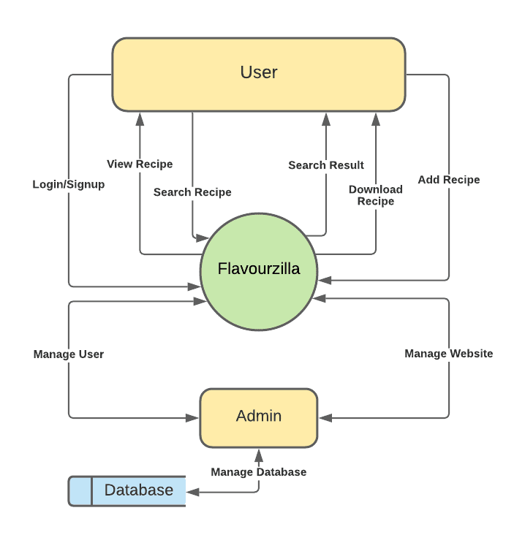

**3.2 UML DIAGRAM**

**3.2.1 Sequence Diagram**

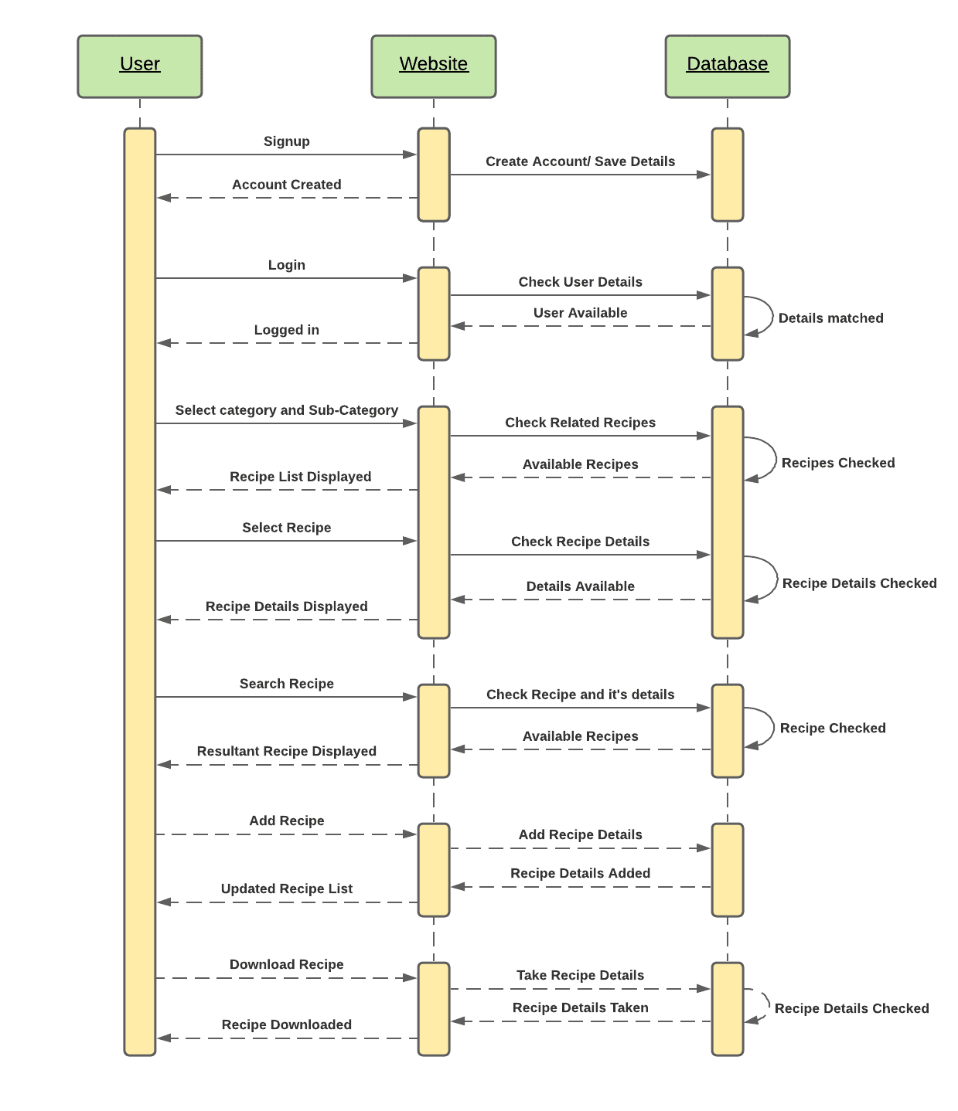

**3.2.3 USE CASE DIAGRAM**

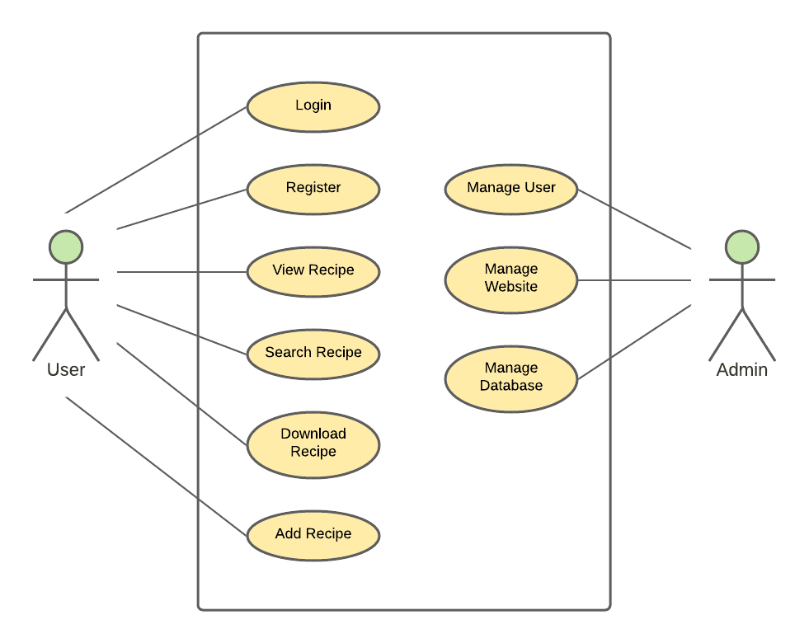

**3.3 DATABASE DESIGN**

**ER DIAGRAM**

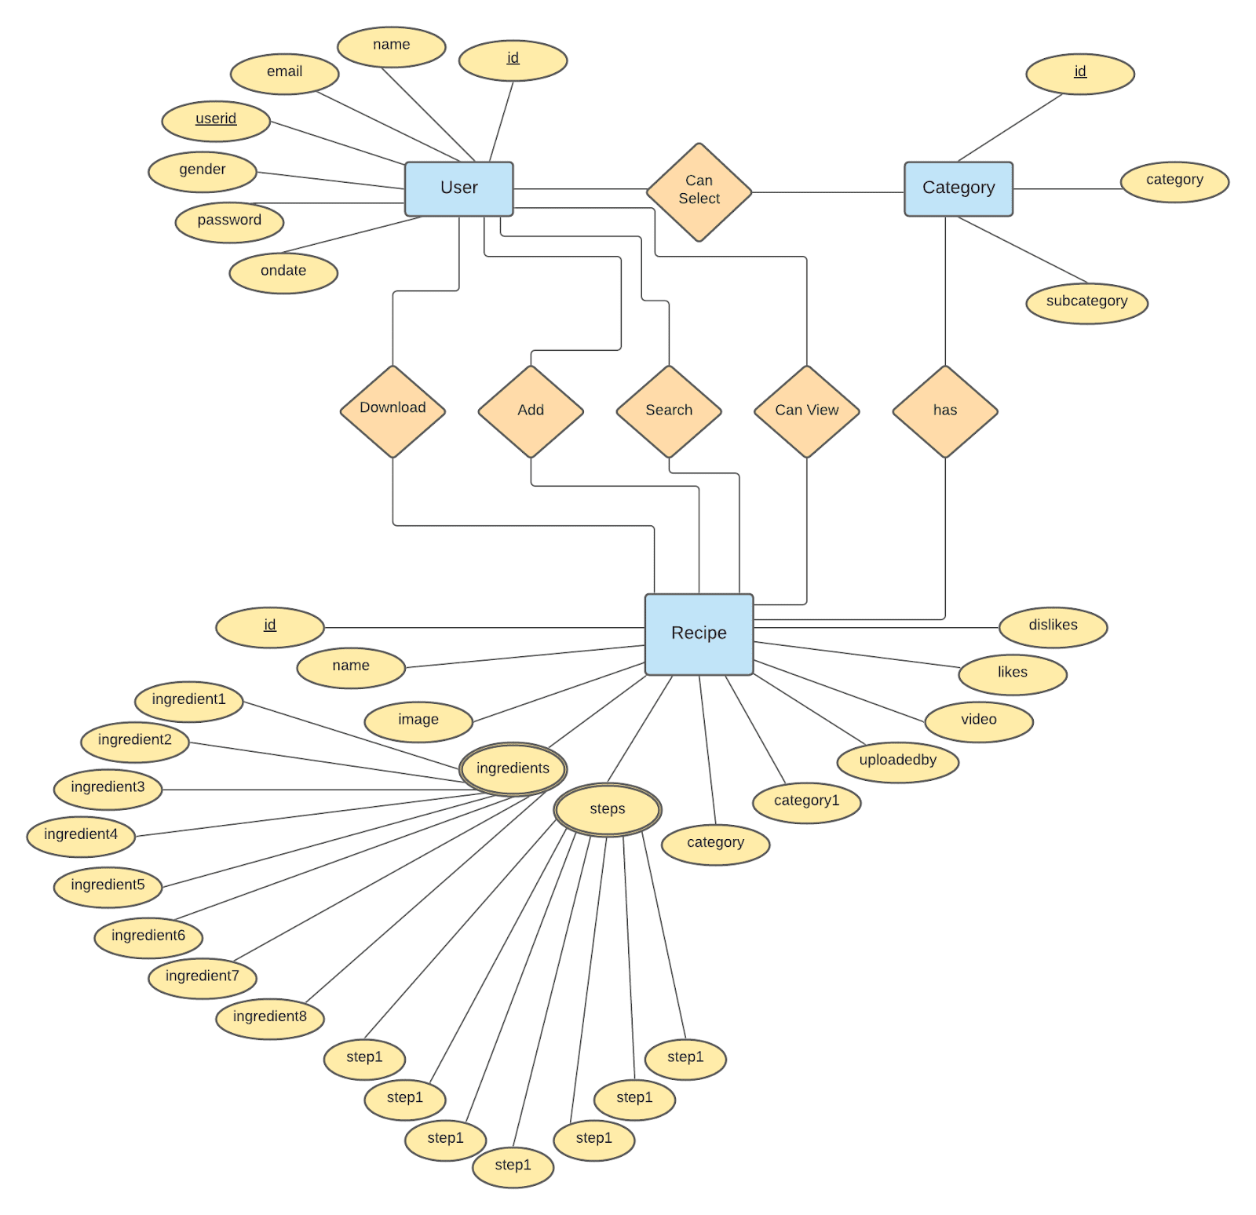

**DATABASE DESCRIPTION**

* + 1. **For User (During Signup)**

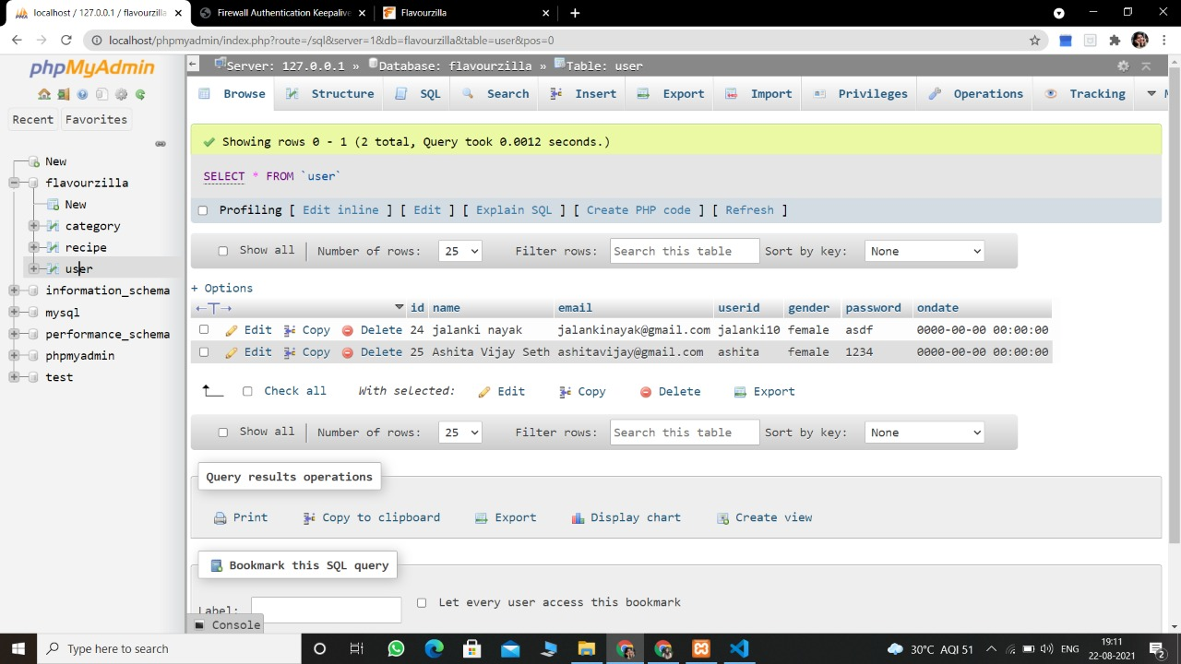

1. **For Category**

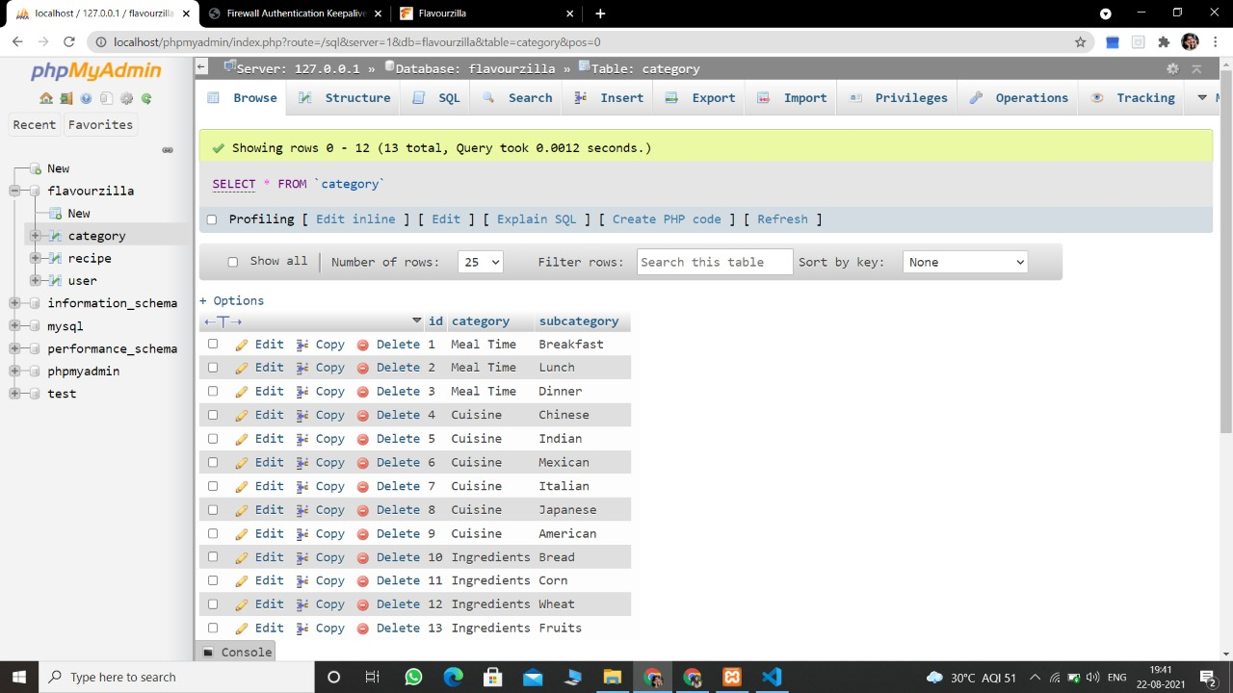

1. **For Recipe**

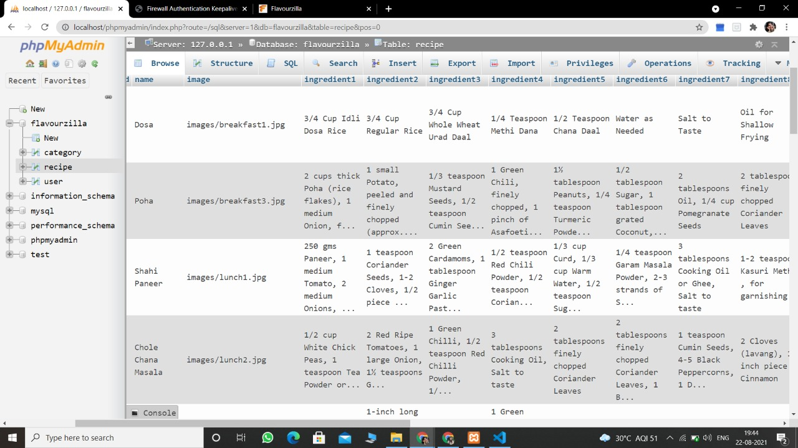

**IMPLEMENTATION AND USER INTERFACE**

* 1. **Welcome (Before Signup/Login)**

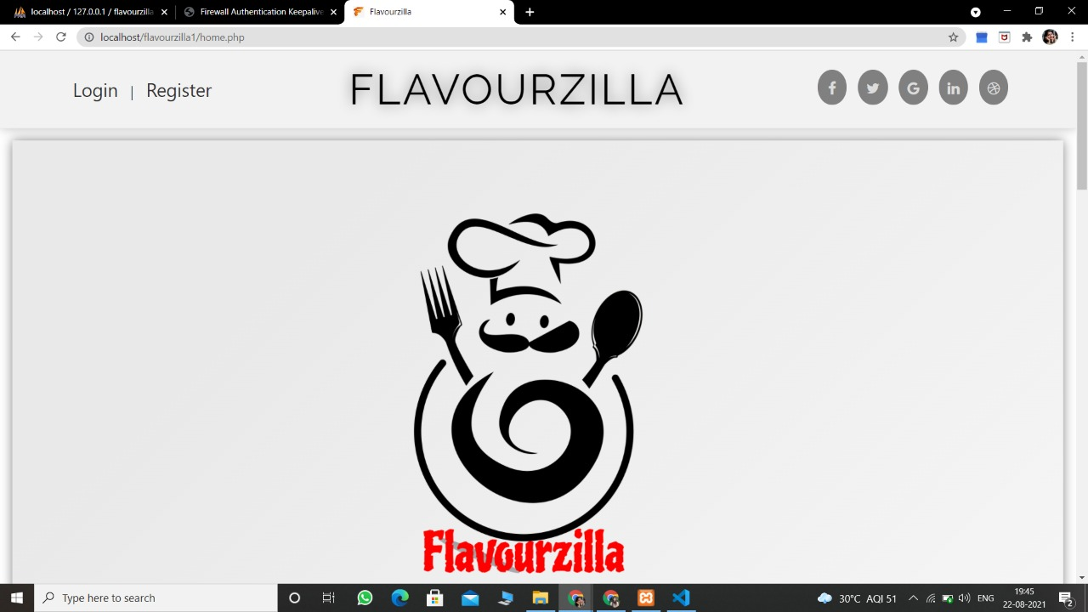

1. **Signup**

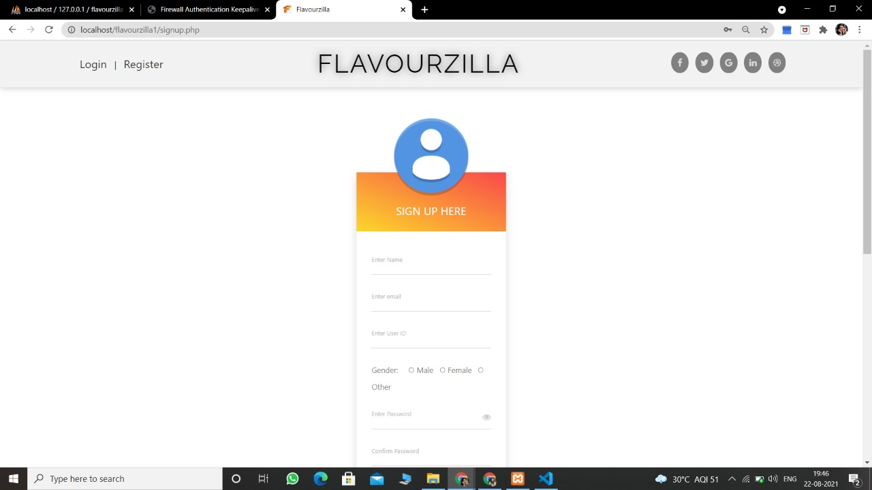

1. **Login**

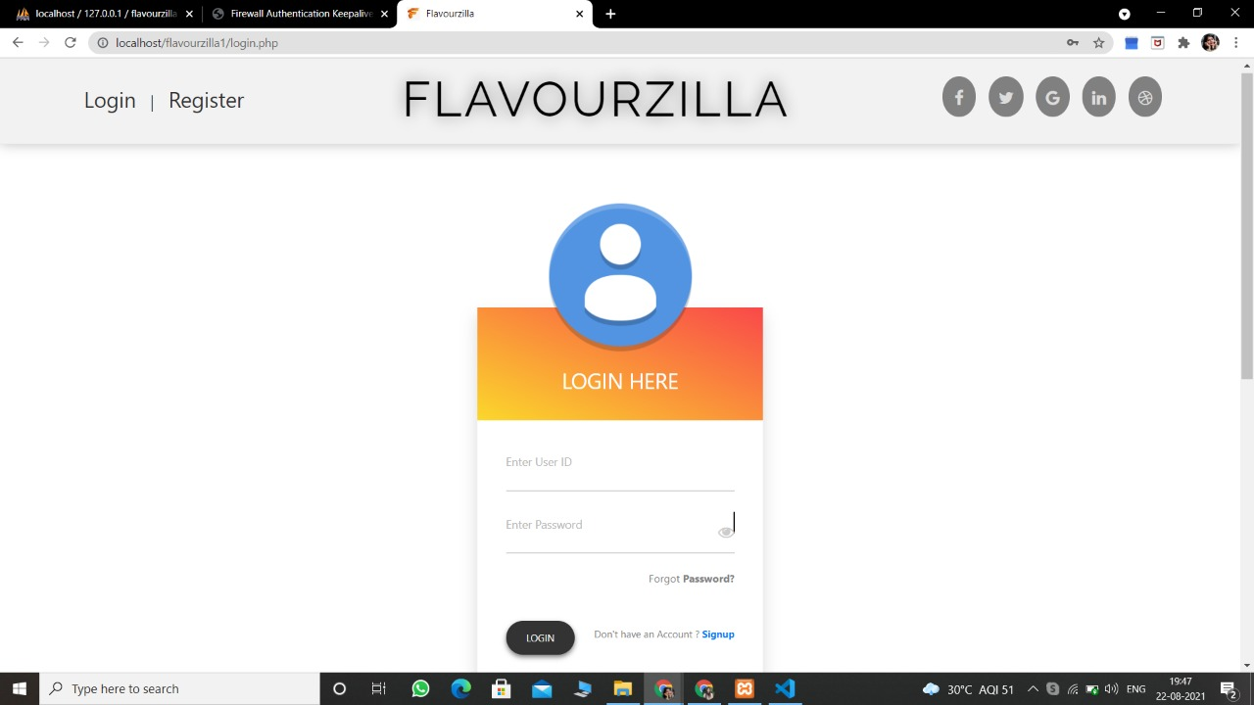

1. **Content Display**

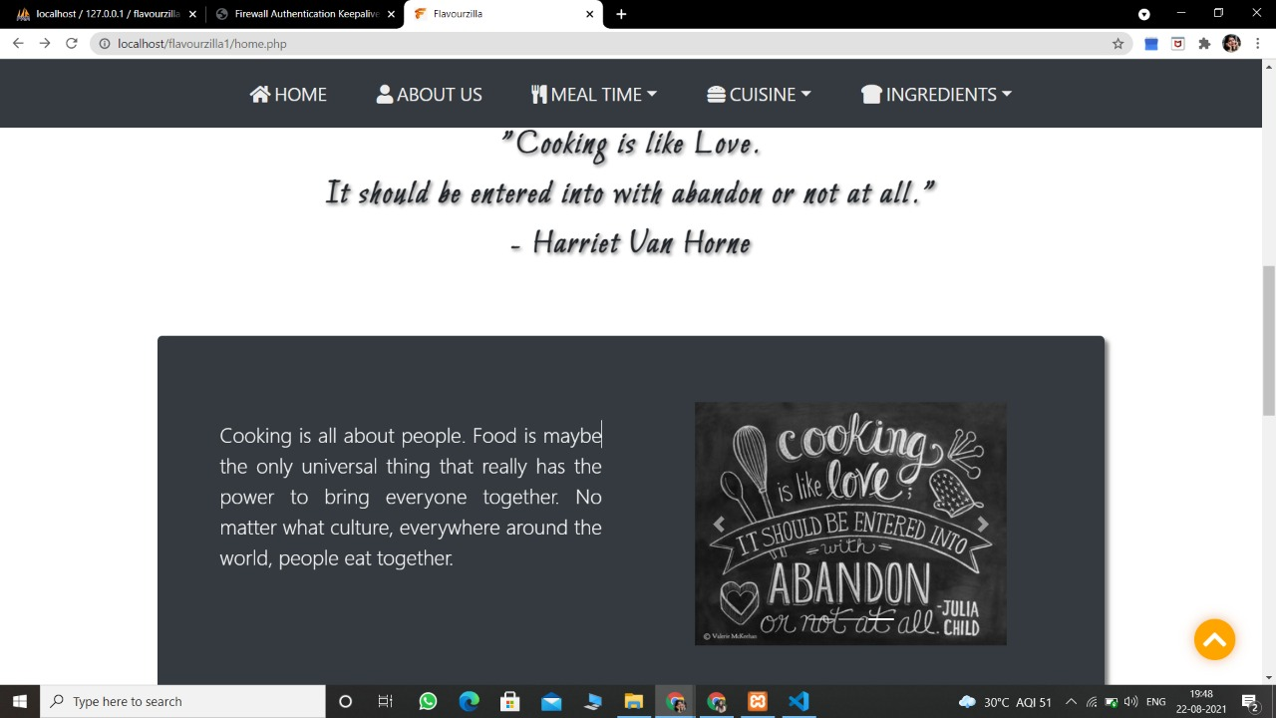

1. **Recipe Details**

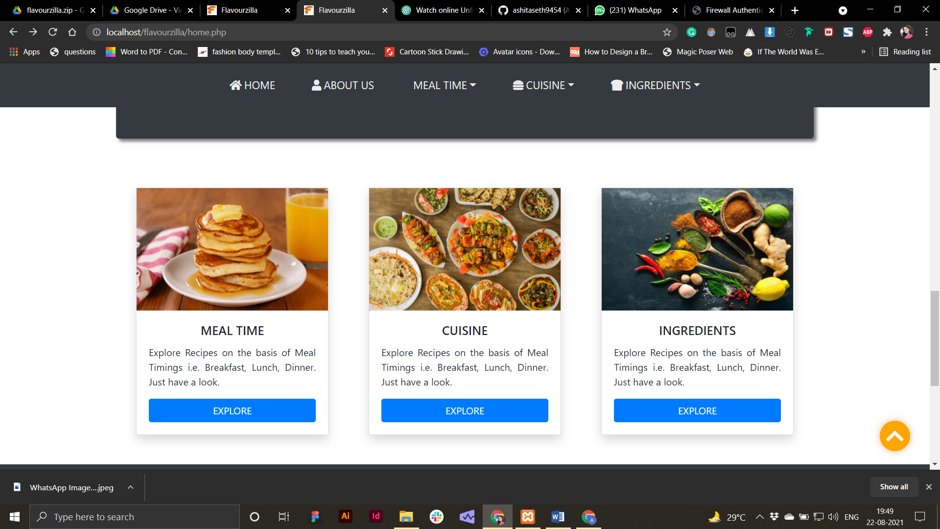

1. **Download Recipe**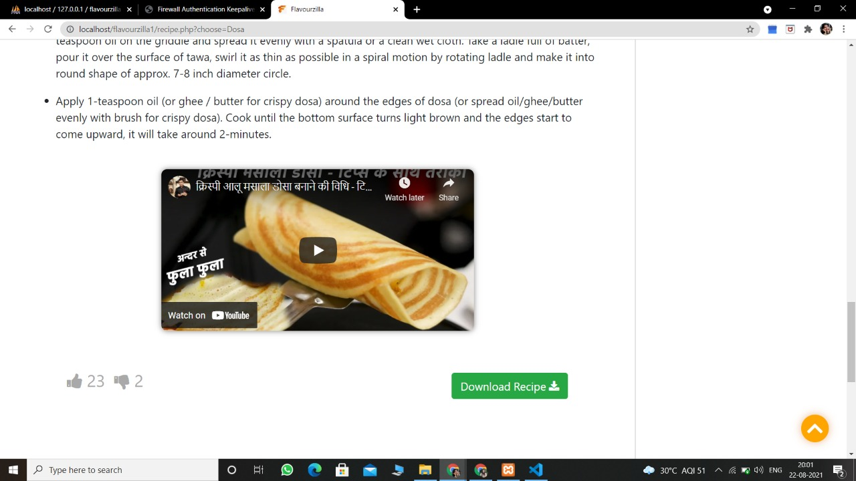

1. **Category Wise Recipes**

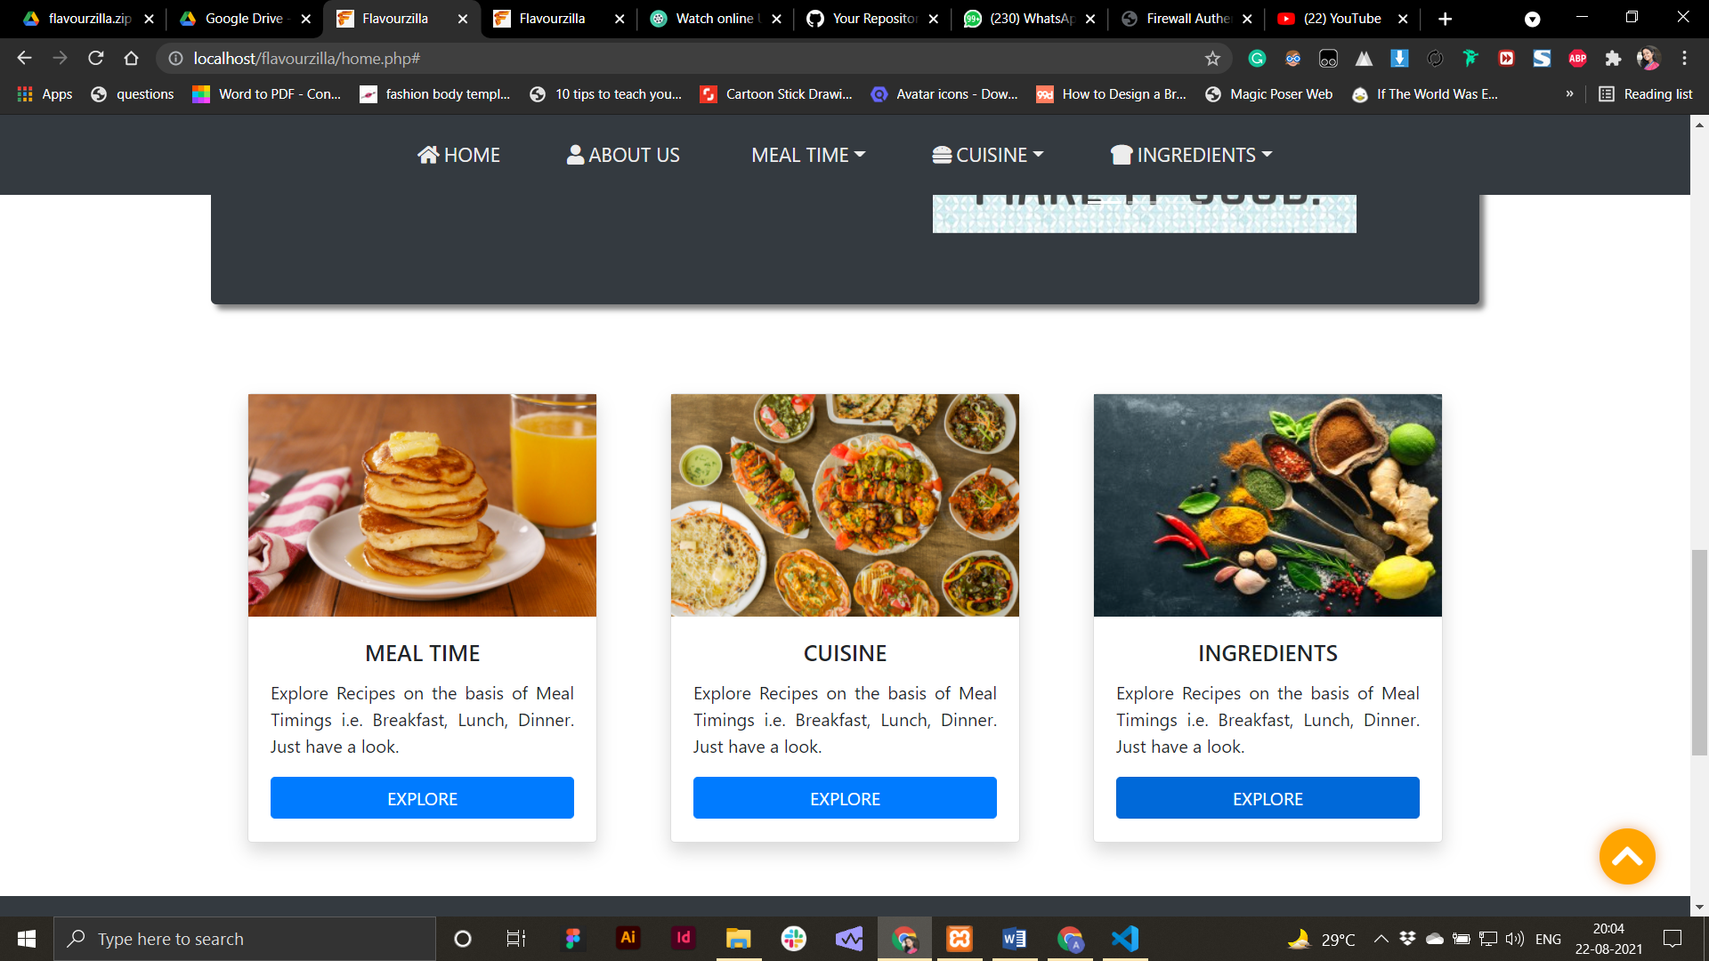

1. **Sub Categories**

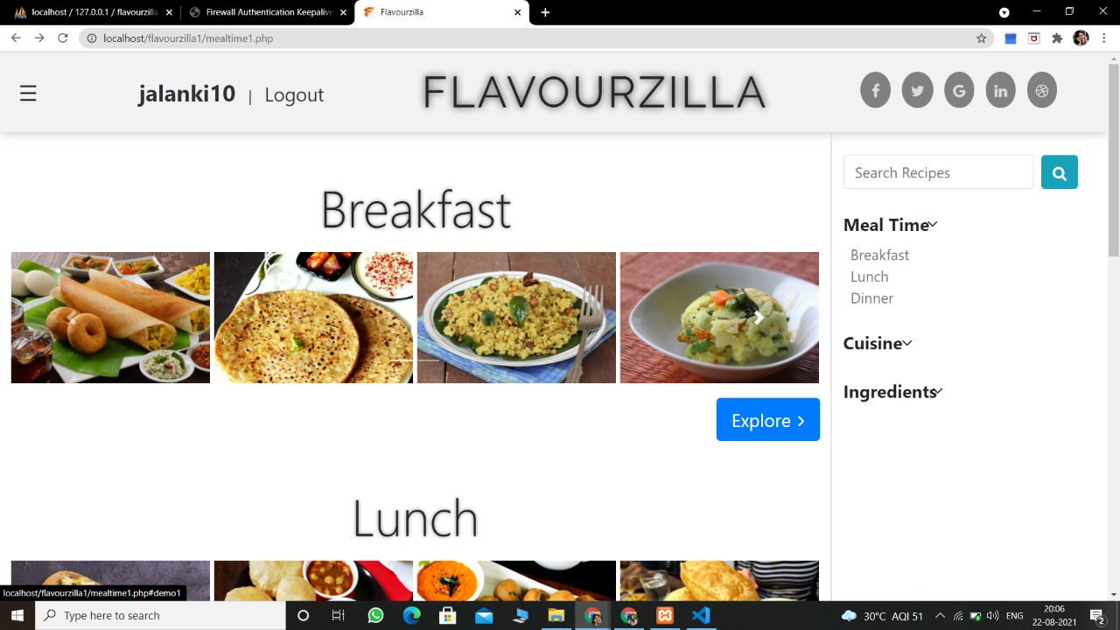

1. **PDF Download of the Recipe**

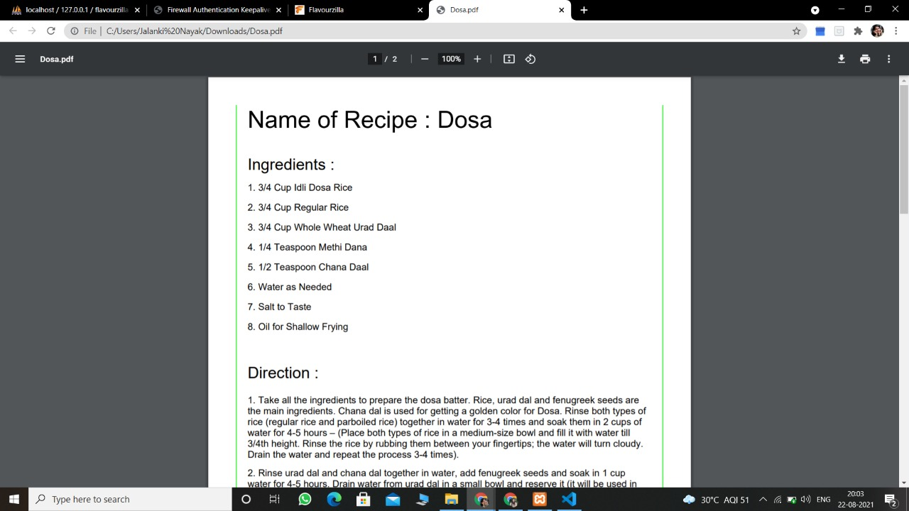

1. **View Recipe**

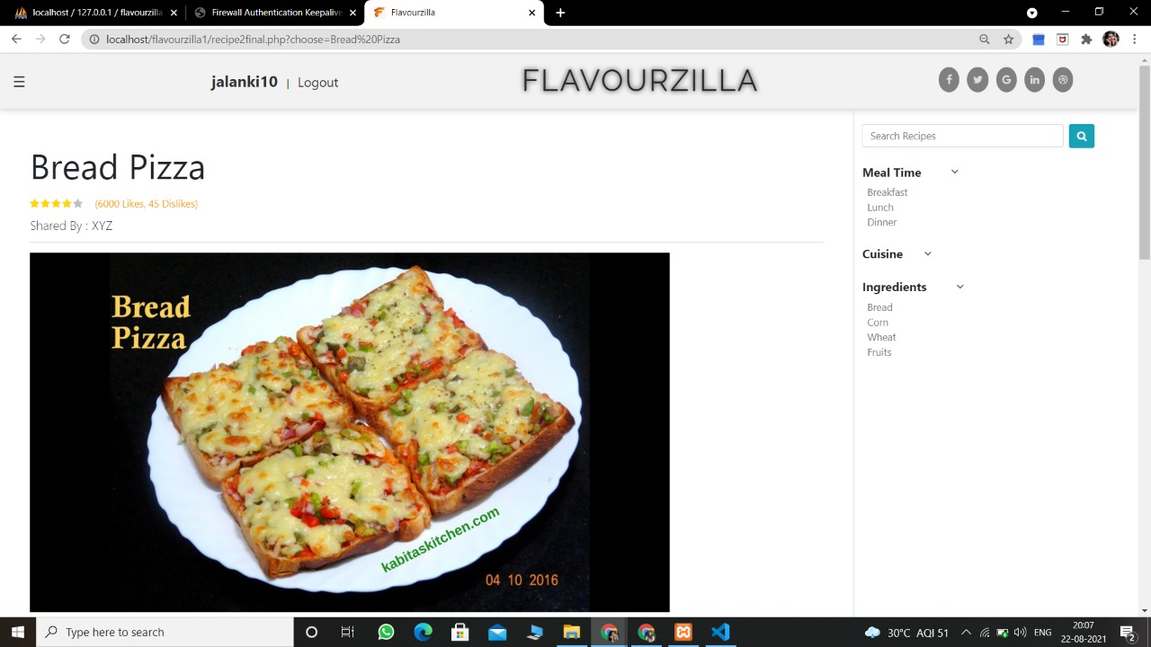

**CONCLUSION AND FUTURE WORK**

From our website **Flavourzilla,** we can solve the issue which was existing in the previous time. Through this website, we are going to bring all the different kinds of food recipes in one place so the user can search and prepare their food with all the ingredients they have. They can even choose a dish according to a meantime or cuisine and can also share their favorite or unique dishes with others.

Following is the link of the Github Repository which shows the detailed Status of the project. Link - <https://github.com/ashitaseth9454/Flavourzilla>

Since no one can be perfect, our website will also require some updates now and then. We can add some rating and commenting action for each recipe so as the user may avail that how much their recipe is appreciated well in the society.

**BIBLIOGRAPHY**

This Project was a huge opportunity and a great source of learning and this Report is the perfect description of this. Many sources helped us in completing this Project and Project Report. Some of them are mentioned below -

1. W3Schools - [https://www.w3schools.com](https://www.w3schools.com/)/
2. YouTube - <https://www.youtube.com/>
3. Lucid Chart - [https://lucid.app/documents/](https://lucid.app/documents#adashboard)
4. Wikipedia - <https://www.wikipedia.org/>
5. Beta-Labs - <http://beta-labs.in/>

**APPENDICES**

